Senior Citizen Request and Assistance Tracking System
Day 2: ERD / Database Design and Wireframes (Checkpoint 1 Preparation)

Database Design Overview
The database has four tables. Three of them (senior_citizens, assistance_types, assistance_requests) are related tables besides users, which satisfies the mini-capstone requirement.
Change from Day 1: the separate request_statuses lookup table is replaced by a status ENUM column in assistance_requests. This keeps the schema to the four required tables and makes the status workflow simpler to code. The same six statuses and workflow rules remain, stored as lowercase enum values (`pending`, `approved`, `rejected`, `in_progress`, `completed`, and `cancelled`). The `assistance_types` table also adds an `is_active` flag so types can be hidden without deletion.
Database name: senior_assistance_db Engine / charset: InnoDB, utf8mb4

Entity Relationship Diagram (ERD)
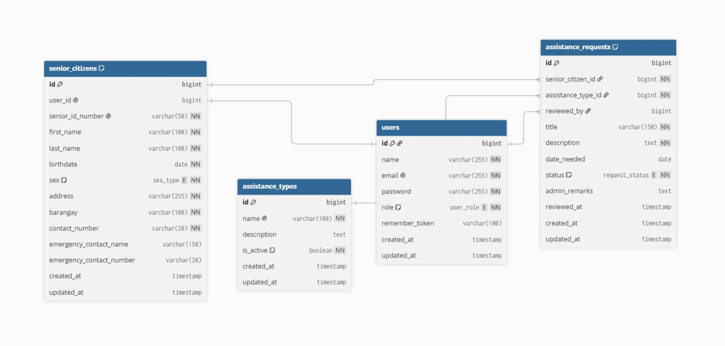
Reading the diagram:
- One users row has zero or one senior_citizens row (admins and walk-in seniors have none).
- One senior_citizens row has many assistance_requests.
- One assistance_types row has many assistance_requests.
- One users row (an admin) can review many assistance_requests through reviewed_by.

Table Definitions

users
Stores login accounts for both roles.
Column | Data Type | Key / Constraint | Notes
id | BIGINT UNSIGNED, auto-increment | PK
name | VARCHAR(255) | NOT NULL | Display name
email | VARCHAR(255) | NOT NULL, UNIQUE | Login identifier
password | VARCHAR(255) | NOT NULL | Hashed (bcrypt)
role | ENUM('admin','senior') | NOT NULL, default senior | Used for role-based access
remember_token | VARCHAR(100) | NULL | Laravel default, optional
created_at | TIMESTAMP | NULL
updated_at | TIMESTAMP | NULL

senior_citizens
Stores the profile and records of each senior citizen.
Column | Data Type | Key / Constraint | Notes
id | BIGINT UNSIGNED, auto-increment | PK
user_id | BIGINT UNSIGNED | FK to users.id, NULL, UNIQUE | Null for walk-in seniors without an account
senior_id_number | VARCHAR(50) | NOT NULL, UNIQUE | Office-issued senior ID
first_name | VARCHAR(100) | NOT NULL
last_name | VARCHAR(100) | NOT NULL
birthdate | DATE | NOT NULL | Age is computed, not stored
sex | ENUM('male','female') | NOT NULL
address | VARCHAR(255) | NOT NULL
barangay | VARCHAR(100) | NOT NULL | Indexed for filtering
contact_number | VARCHAR(20) | NOT NULL
emergency_contact_name | VARCHAR(150) | NULL
emergency_contact_number | VARCHAR(20) | NULL
created_at | TIMESTAMP | NULL
updated_at | TIMESTAMP | NULL

Foreign key: user_id references users(id) with ON DELETE SET NULL. Deleting an account does not delete the senior's record.
Indexes: unique on senior_id_number, unique on user_id, index on barangay, index on (last_name, first_name).

assistance_types
Categories of assistance the office offers (for example Medical, Financial, Food, Transportation).
Column | Data Type | Key / Constraint | Notes
id | BIGINT UNSIGNED, auto-increment | PK
name | VARCHAR(100) | NOT NULL, UNIQUE
description | TEXT | NULL
is_active | BOOLEAN | NOT NULL, default true | Inactive types are hidden from the request form
created_at | TIMESTAMP | NULL
updated_at | TIMESTAMP | NULL

assistance_requests
The main transaction table. Each row is one request from one senior citizen.
Column | Data Type | Key / Constraint | Notes
id | BIGINT UNSIGNED, auto-increment | PK
senior_citizen_id | BIGINT UNSIGNED | FK to senior_citizens.id, NOT NULL | Who is requesting
assistance_type_id | BIGINT UNSIGNED | FK to assistance_types.id, NOT NULL | What kind of help
reviewed_by | BIGINT UNSIGNED | FK to users.id, NULL | Admin who approved or rejected
title | VARCHAR(150) | NOT NULL | Short summary
description | TEXT | NOT NULL | Details of the need
date_needed | DATE | NULL
status | ENUM('pending','approved','rejected','in_progress','completed','cancelled') | NOT NULL, default pending | See workflow below
admin_remarks | TEXT | NULL | Required when rejecting
reviewed_at | TIMESTAMP | NULL | Set on approve or reject
created_at | TIMESTAMP | NULL
updated_at | TIMESTAMP | NULL

Foreign keys
FK Column | References | On Delete
senior_citizen_id | senior_citizens(id) | CASCADE (deleting a senior removes their requests)
assistance_type_id | assistance_types(id) | RESTRICT (a type in use cannot be deleted)
reviewed_by | users(id) | SET NULL

Indexes: index on status, index on senior_citizen_id, index on assistance_type_id.
Status workflow (unchanged from Day 1): pending to approved or rejected or cancelled; approved to in_progress; in_progress to completed. Rejected, completed, and cancelled are final.

Relationship Summary
Relationship | Type | Foreign Key | Laravel Eloquent
users to senior_citizens | One-to-one (optional) | senior_citizens.user_id | User hasOne SeniorCitizen; SeniorCitizen belongsTo User
senior_citizens to assistance_requests | One-to-many | assistance_requests.senior_citizen_id | SeniorCitizen hasMany AssistanceRequest; AssistanceRequest belongsTo SeniorCitizen
assistance_types to assistance_requests | One-to-many | assistance_requests.assistance_type_id | AssistanceType hasMany AssistanceRequest; AssistanceRequest belongsTo AssistanceType
users to assistance_requests (reviewer) | One-to-many | assistance_requests.reviewed_by | User hasMany AssistanceRequest (as reviewer); AssistanceRequest belongsTo User (as reviewer)

Requirement check: the system has three related tables besides users (senior_citizens, assistance_types, assistance_requests) with three one-to-many relationships.

Wireframes (React Pages)
Low-fidelity layouts for each React page. Admin pages share a sidebar layout; senior pages share a top navbar layout. The senior dashboard is a Day 2 addition and is the landing page after senior login.

Login (`/login`)
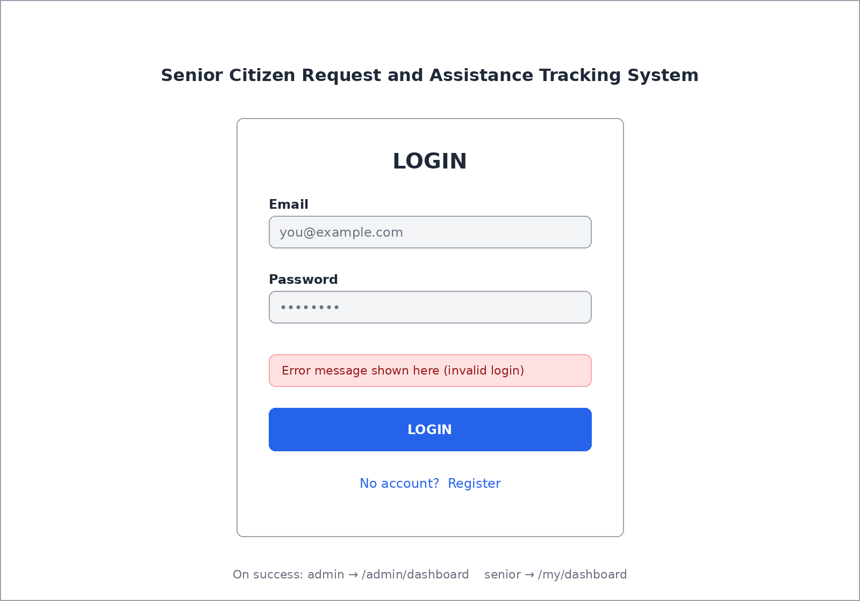
On success, admin goes to /admin/dashboard and senior goes to /my/dashboard.

Register (`/register`)
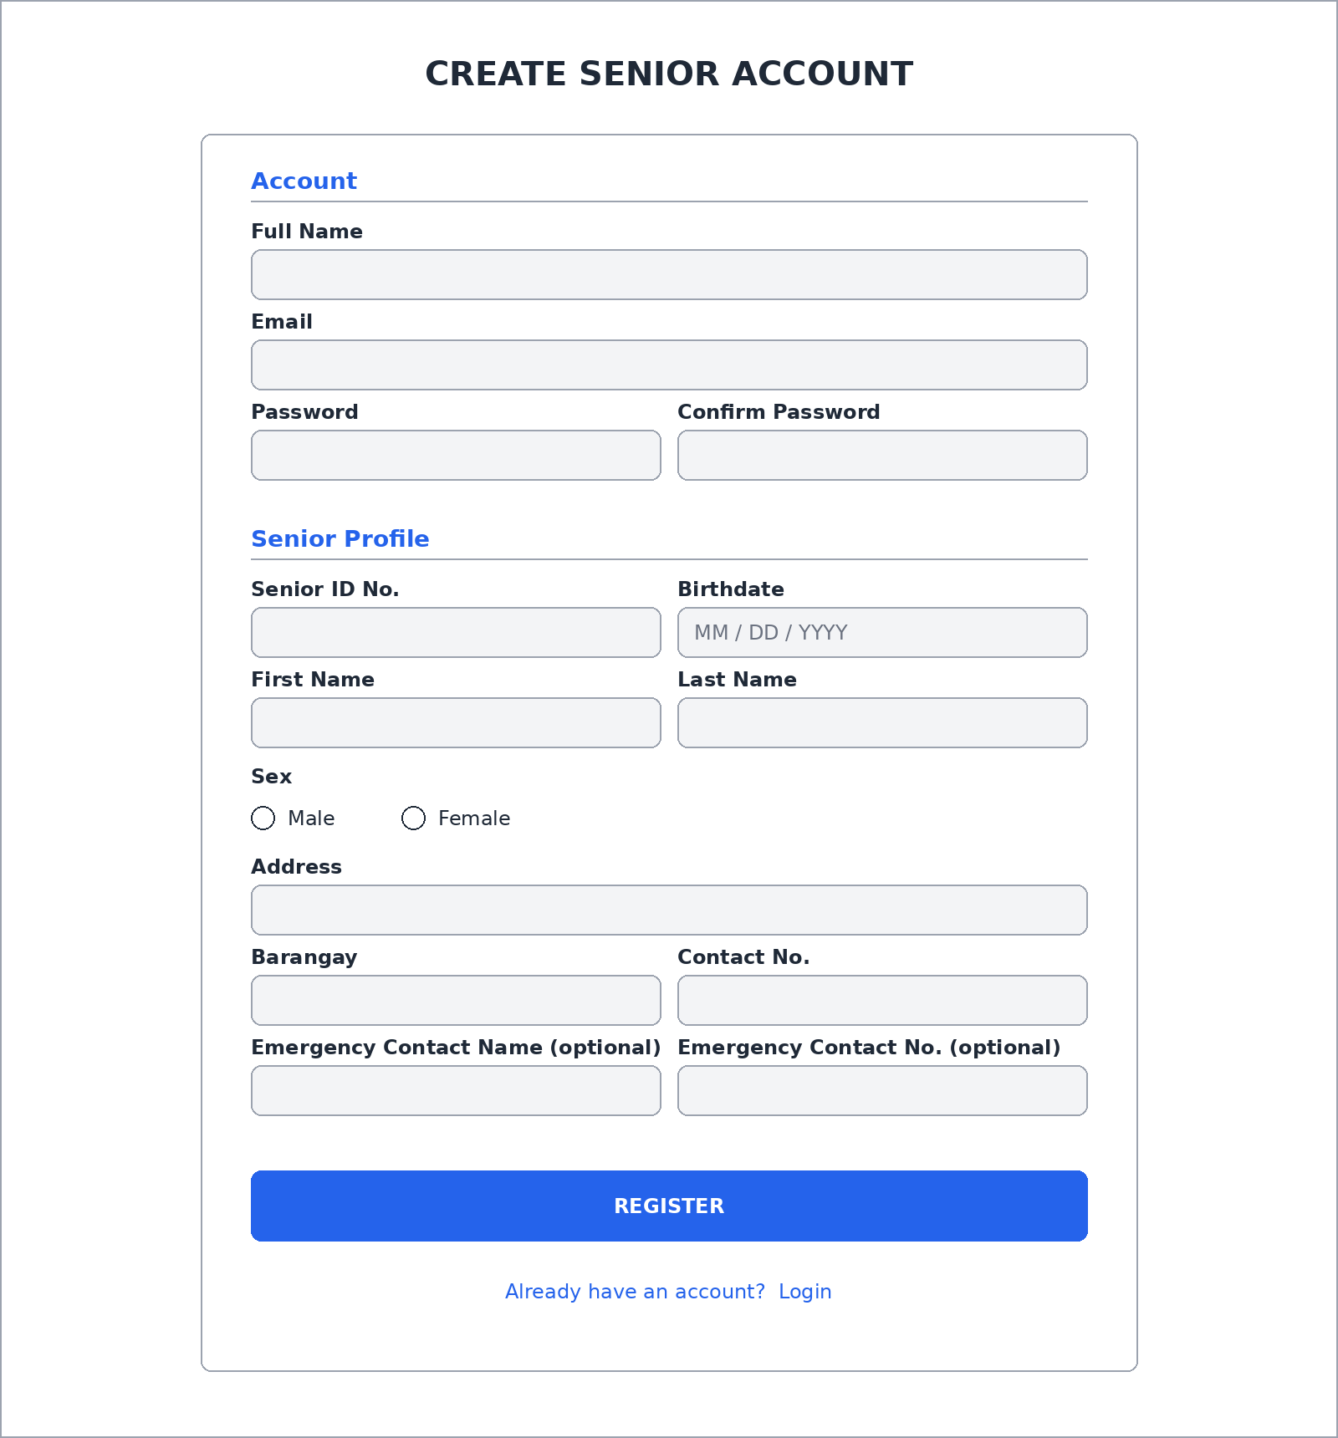

Admin Dashboard (`/admin/dashboard`)
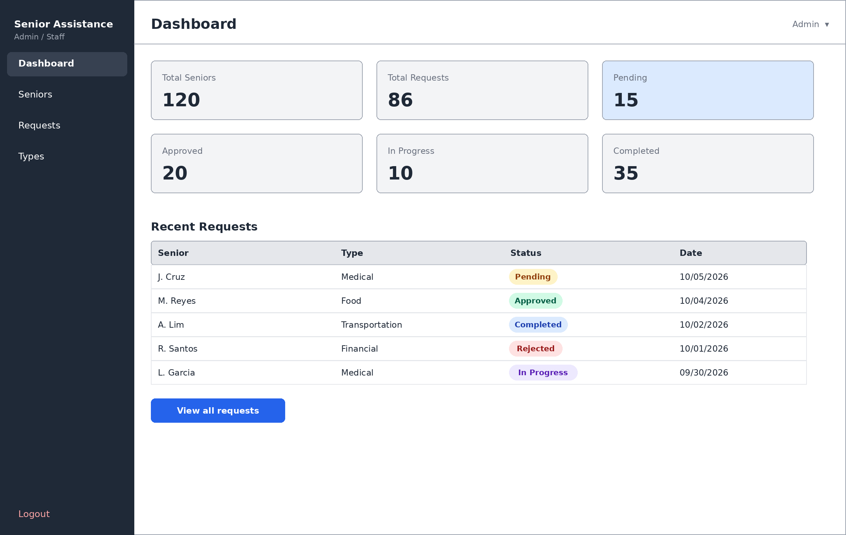

Senior Citizen Dashboard (`/my/dashboard`)
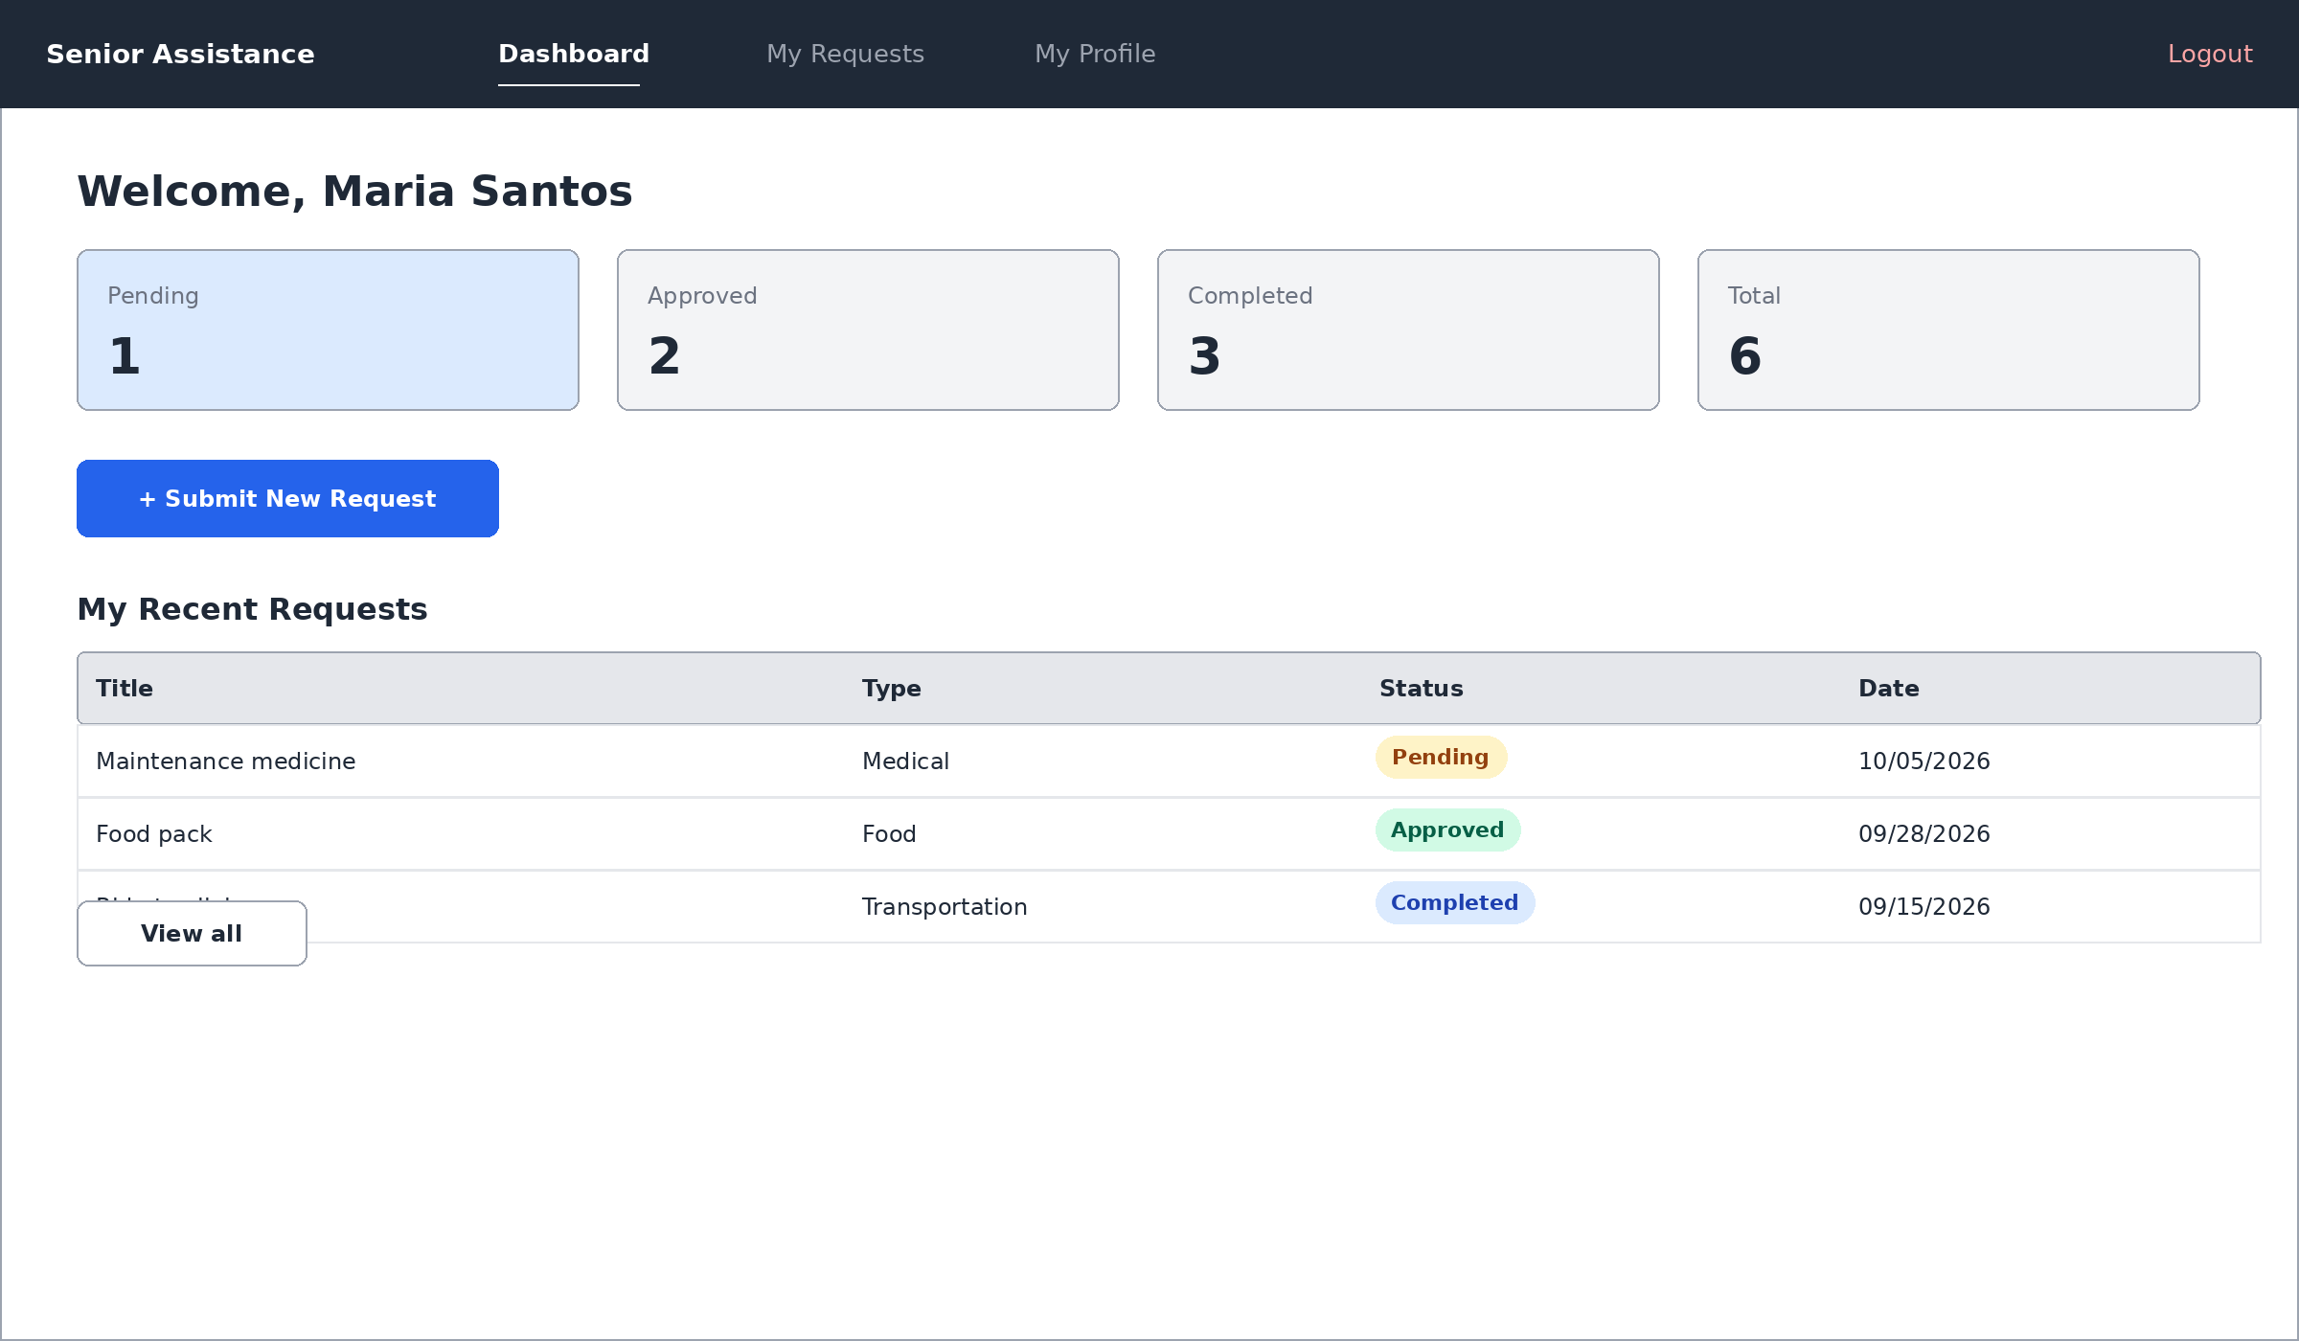

Senior Citizens List (`/admin/seniors`)
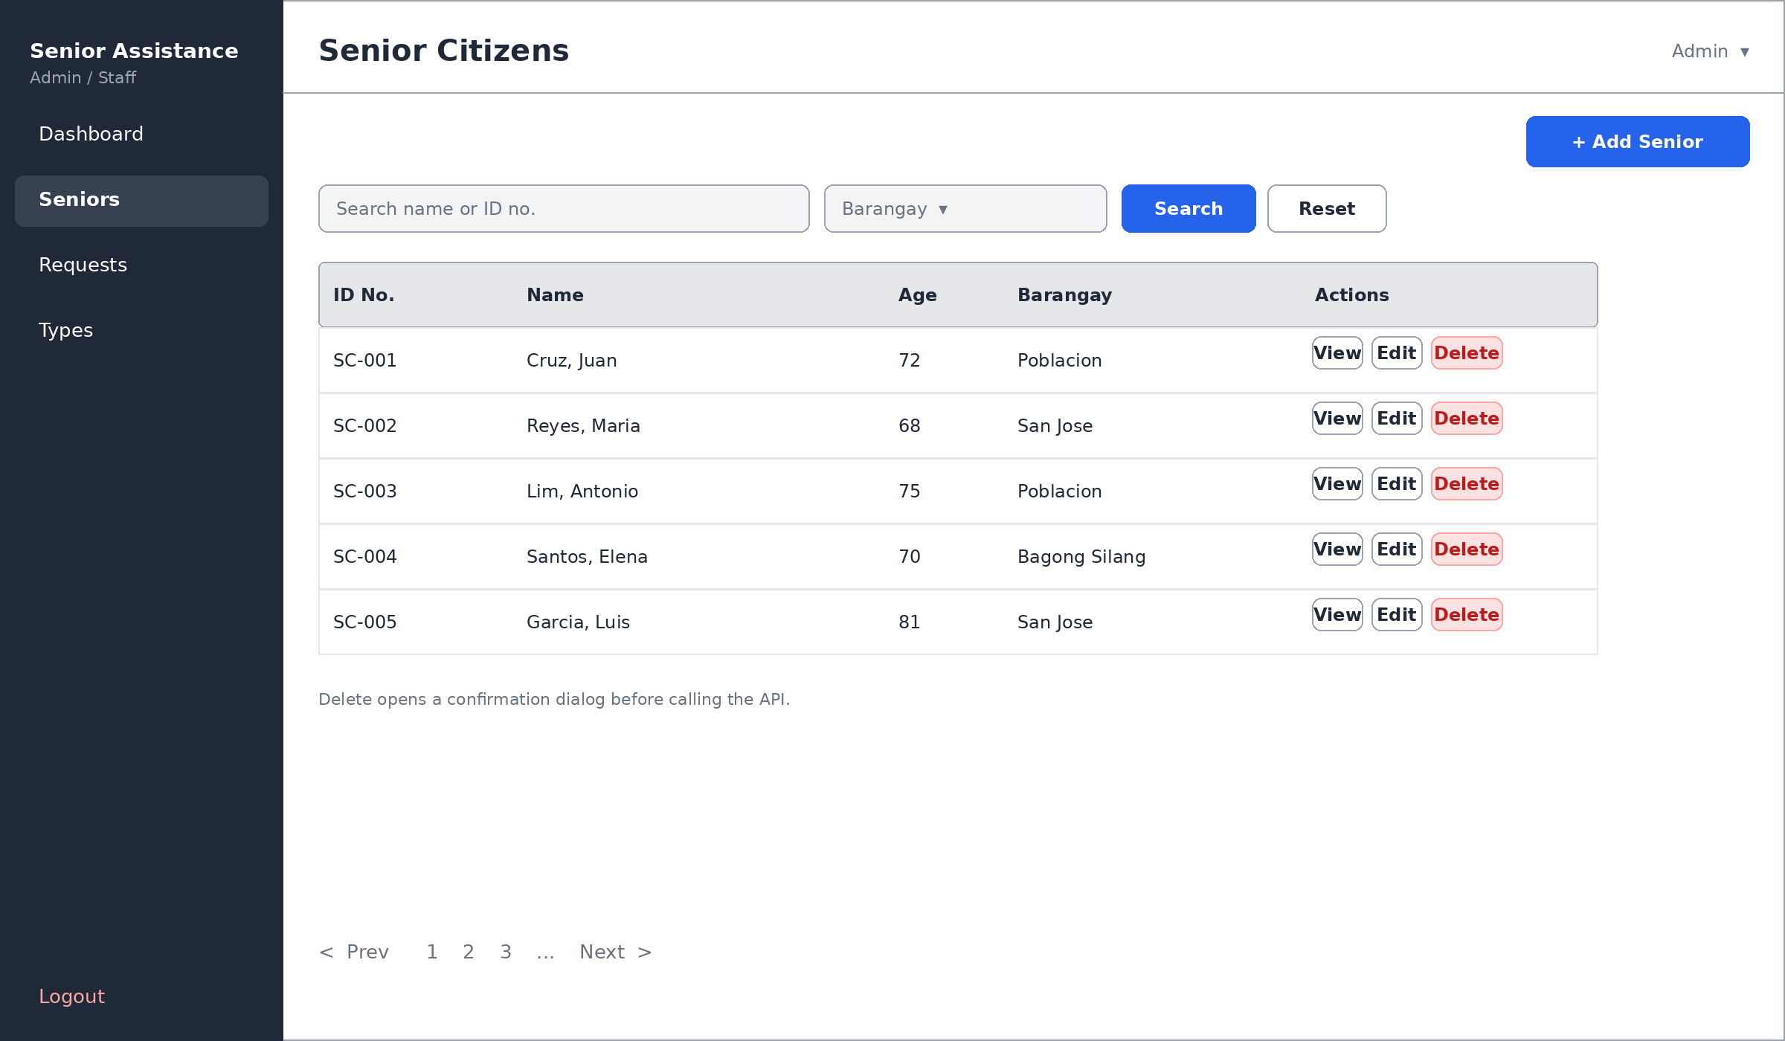
The Delete action opens a confirmation dialog before calling the API. The Add and Edit pages use the same form fields as the Register page's "Senior Profile" section.

Assistance Requests List (`/admin/requests`)
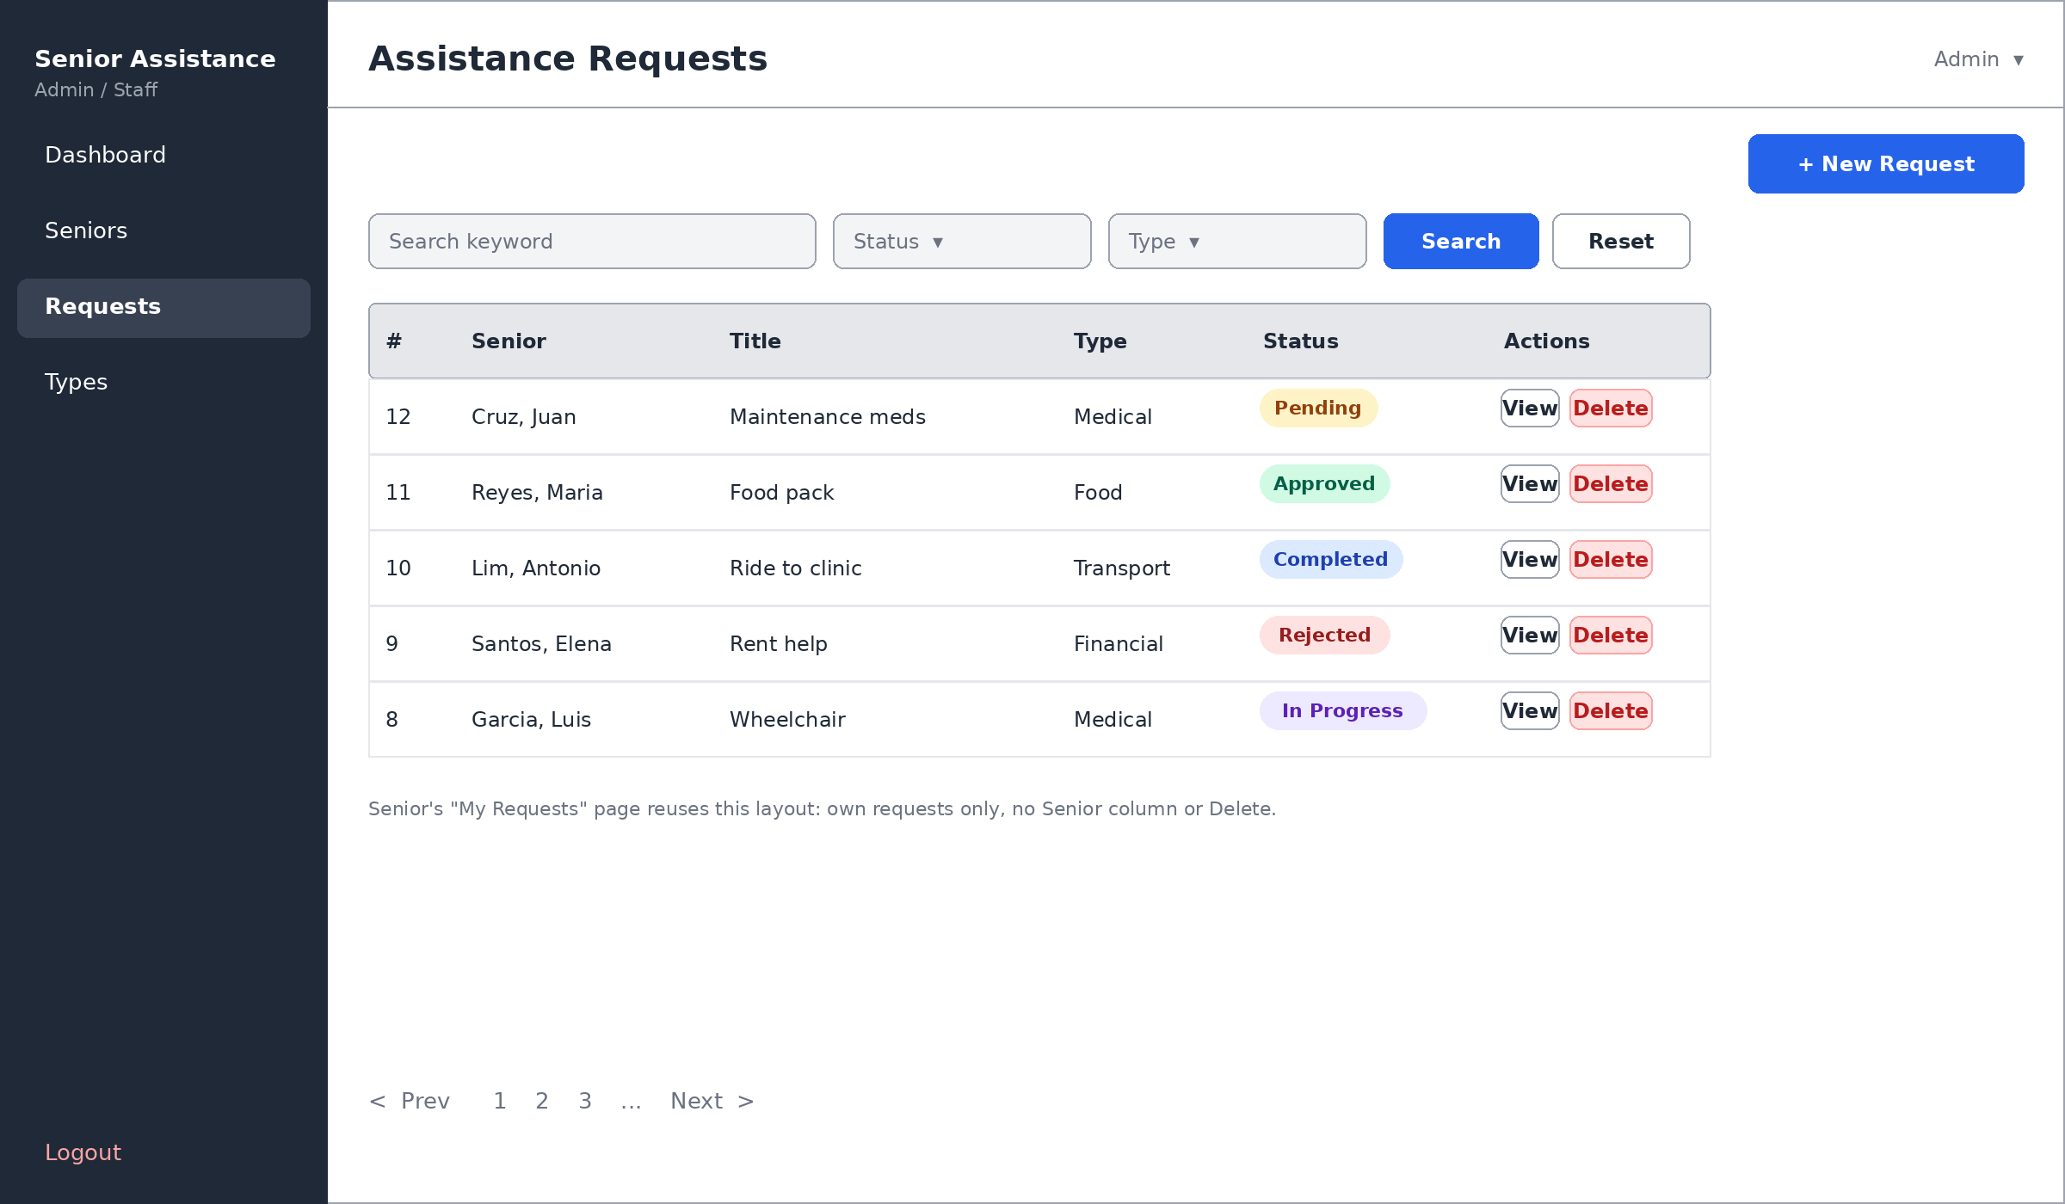
The same layout is reused for the senior's My Requests page (/my/requests), but it shows only their own requests, without the Senior column or the Delete action.

Assistance Request Form (`/my/requests/new`, also used for edit)
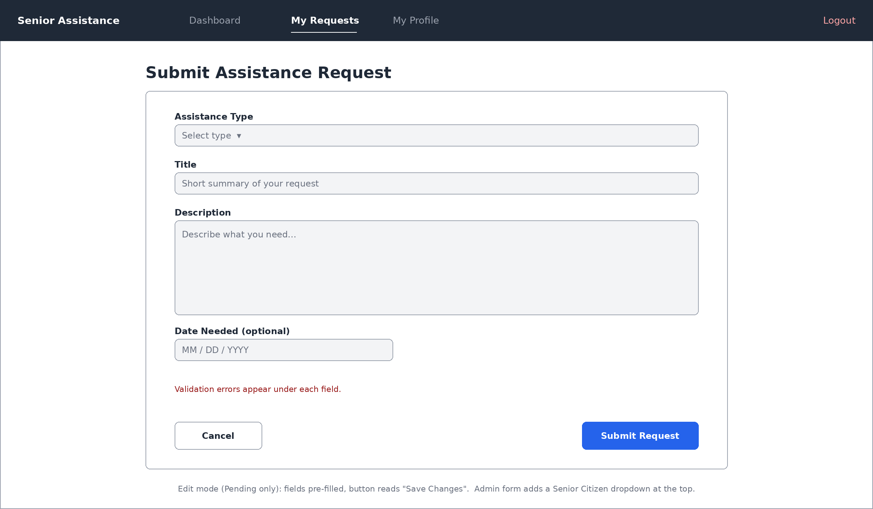
In edit mode (Pending requests only) the fields are pre-filled and the button reads "Save Changes". When admin uses this form (/admin/requests/new), an extra Senior Citizen dropdown appears at the top.

Request Details (`/my/requests/:id` and `/admin/requests/:id`)
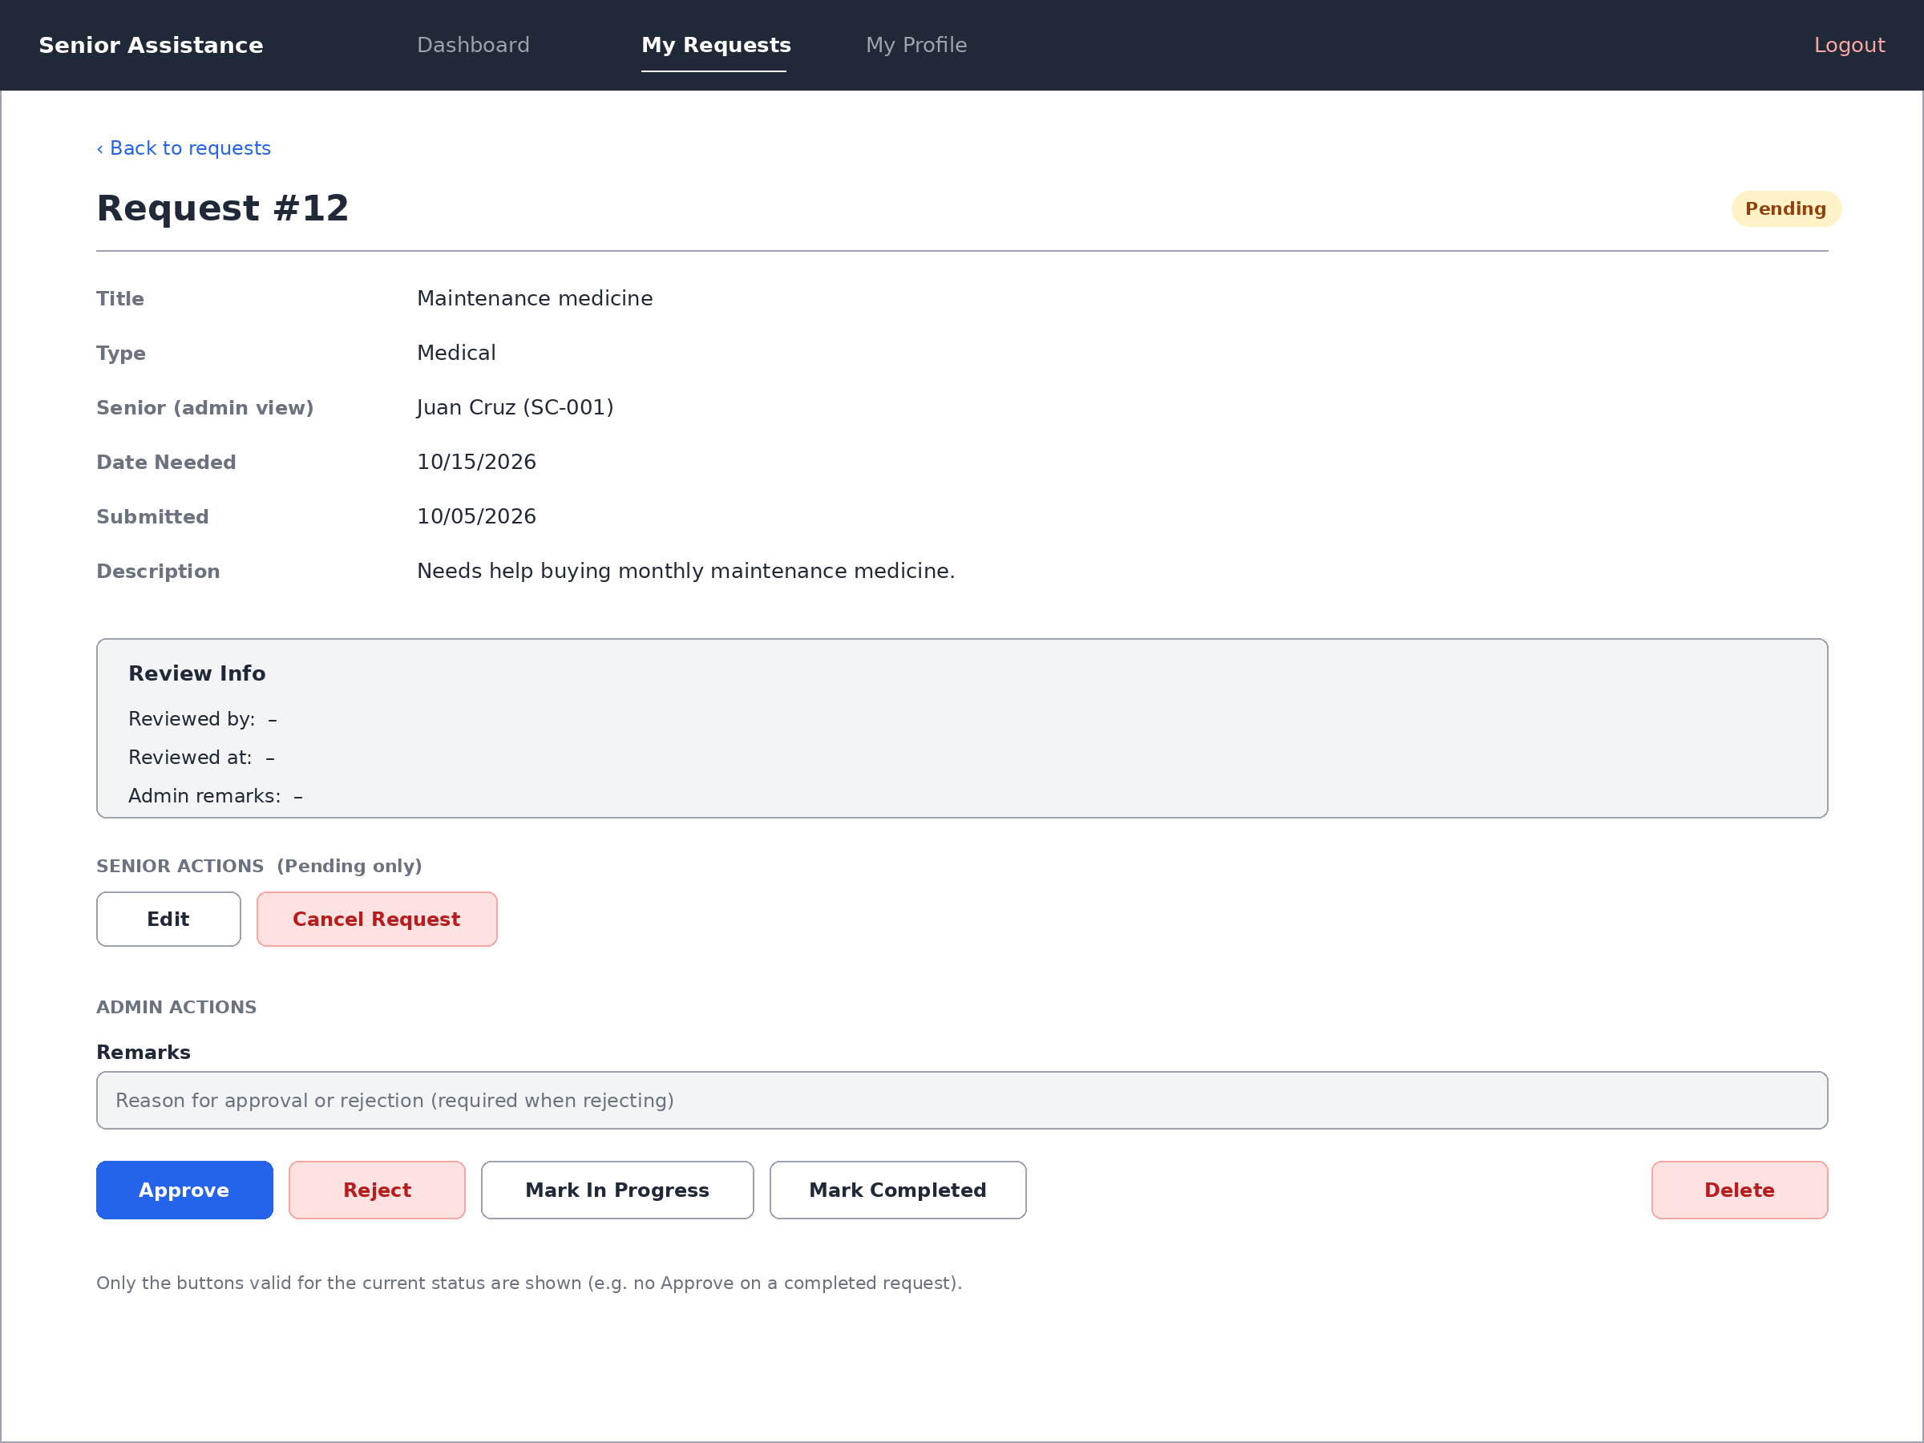
Only buttons valid for the current status are shown (for example, no Approve button on a completed request).

